Document Title: “Day 3 – API Integration Report - [Mahnoor E-Commerce]”

What to submit:

A report documenting:

1) API integration process.

2) Adjustments made to schemas.

3) Migration steps and tools used.

Screenshots of :

1. API calls.
2. Data successfully displayed in the frontend.
3. Populated sanity CMS fields.
4. Code snippets for API integration and migration scripts.

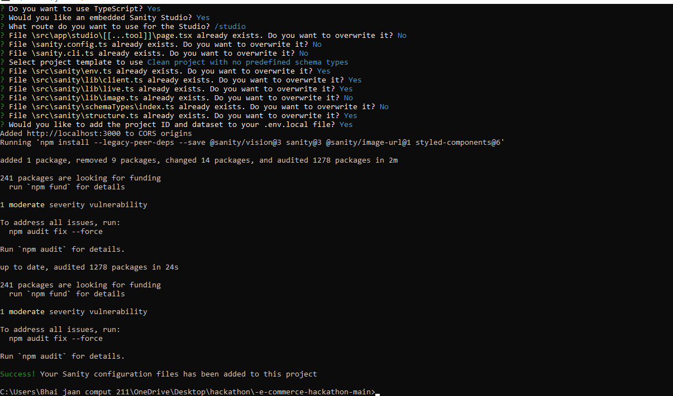

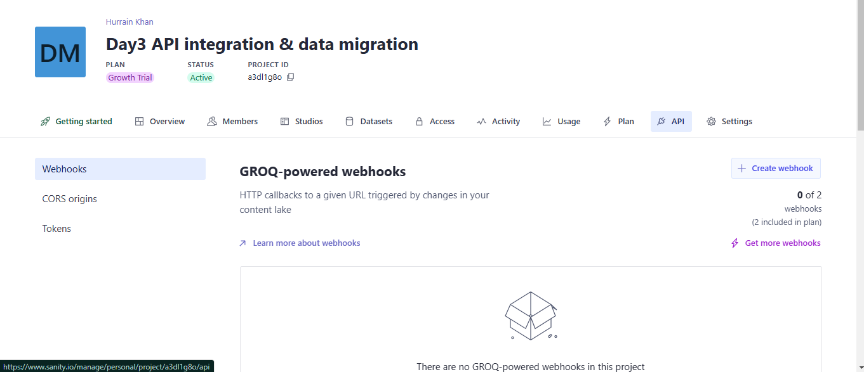

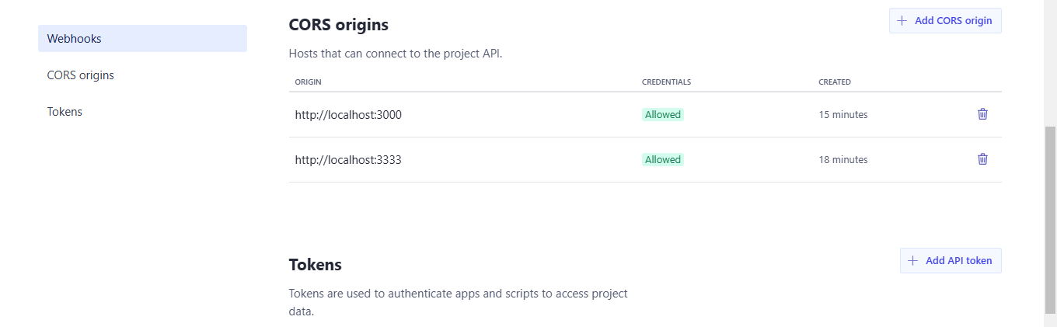

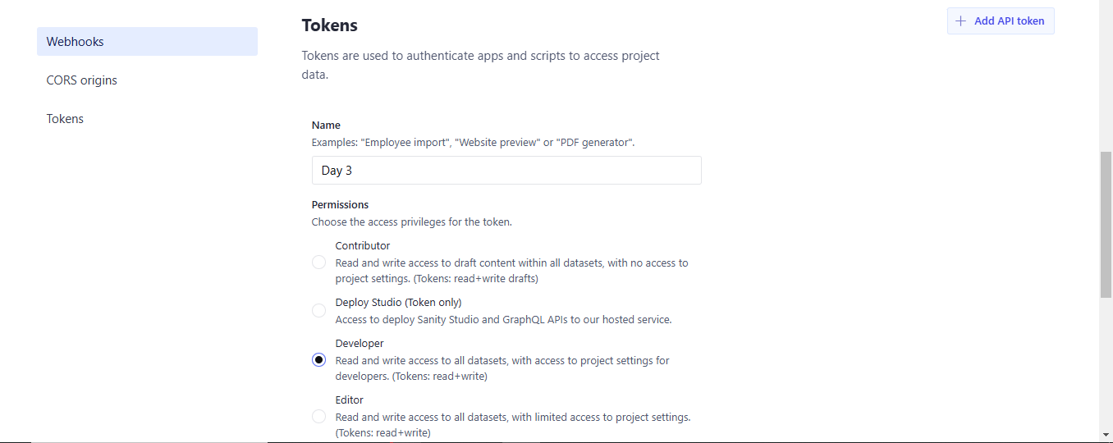

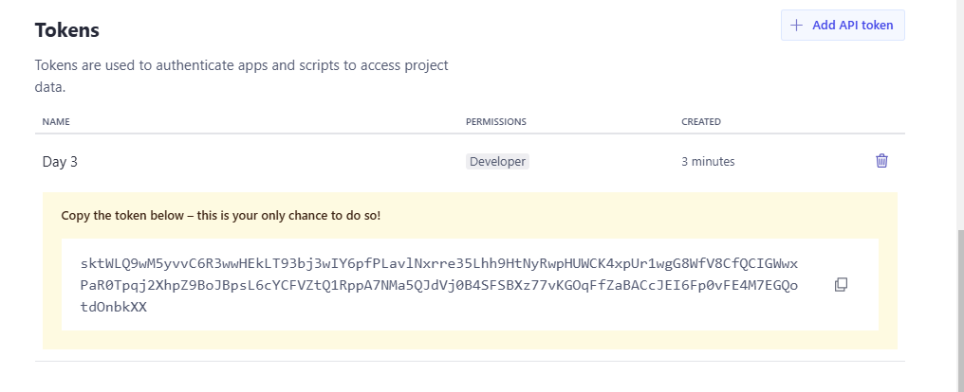

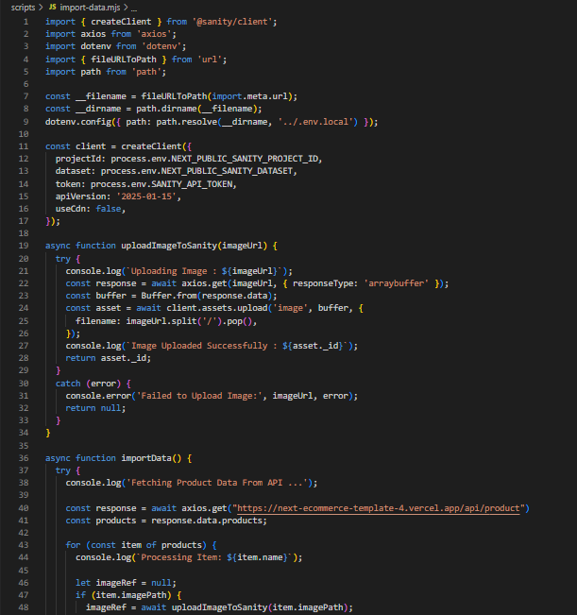

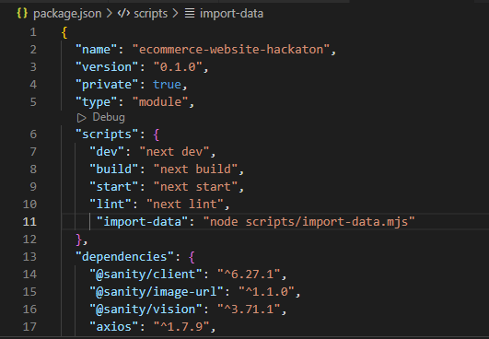

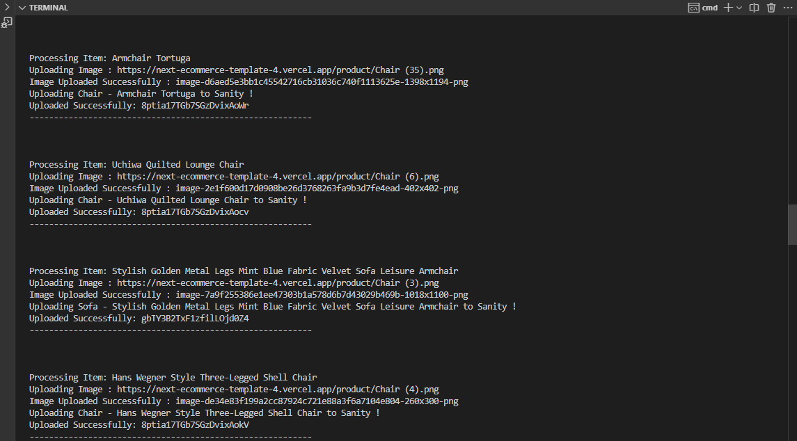

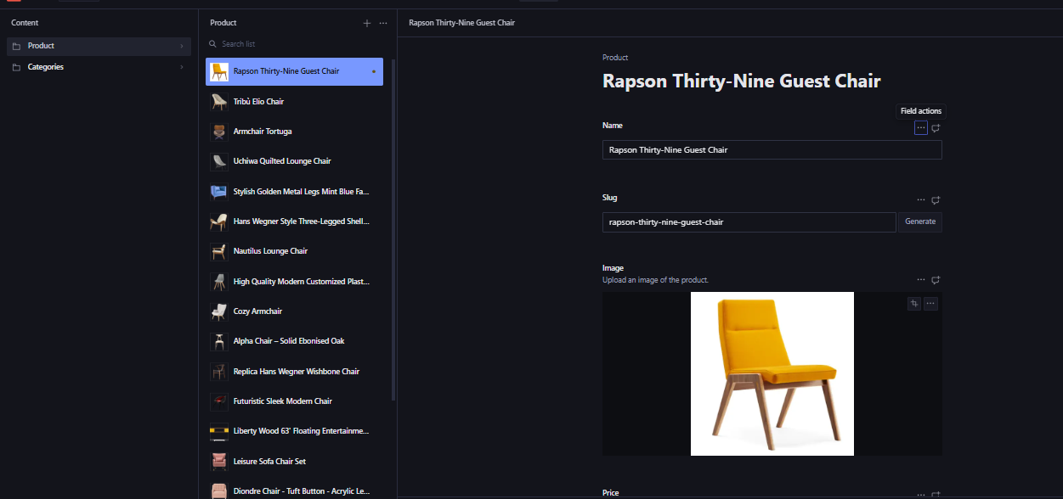

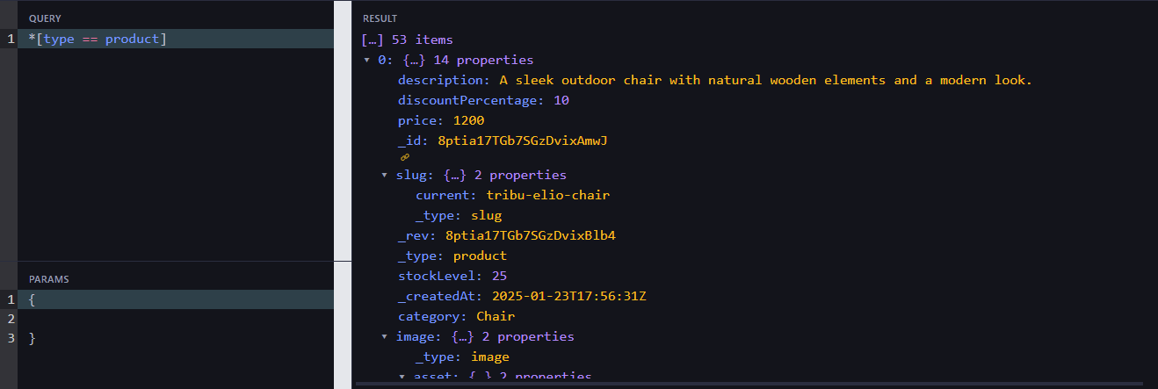

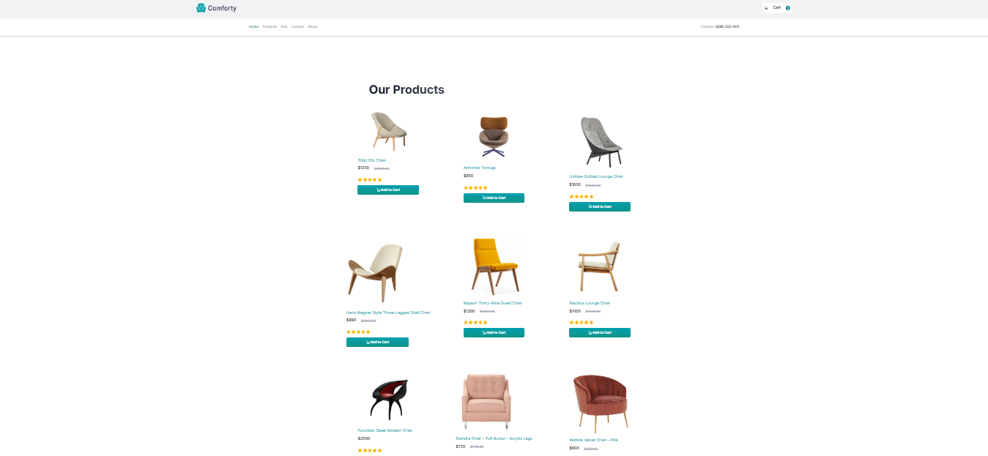

Conclusion:

The API integration & data migration processes were completed Successfully!